What to Do when the Fascists Table at Your Campus

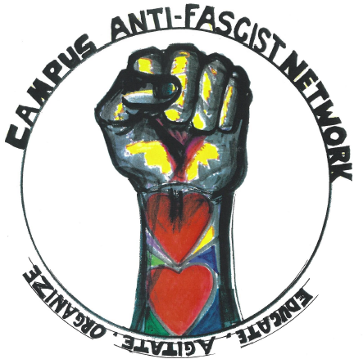
The arrival of the new semester has brought with it a resurgence of fascist, crypto-fascist, and alt-right recruiting efforts on college and university campuses. Such activities range from covertly posting flyers and temporarily hacking college printers to more public-facing activities ranging from meetings to tabling with far-right propaganda. The following document is intended to provide a series of general steps for effectively neutralizing the potential threat of a fascist or “alt-right” tabling. Readers are strongly encouraged to carefully research the specific organization, or organizations, actively tabling on a specific campus in order to more effectively determine if this form of indirect confrontation is strategically safe and appropriate. CAN’s “Antifascist Syllabus” is one such resource. The information provided here has been kept intentionally broad to facilitate adaptation to different organizing landscapes. If more specific information is requested, please contact us at cannetwork.fighttheh8@gmail.com.

- In any confrontation with fascists and/or their allies, numbers are key. It is ideal to undertake the public actions suggested here when the fascist organization’s members are outnumbered by a ratio of 3 or 4 to 1. This is in order to insure the personal safety of all involved.
- Table for CAN or a similar organization directly opposite or nearby the hostile organization’s activities. Ask the campus Black Student Union, LGBTQ, Sanctuary Campus, Indigenous, Feminist, Muslim, Latinx, or other allied groups to join in your tabling activities, or coordinate timing with them as a sign of solidarity and to guarantee safety.
- Hold an audible, recurring “teach-in” with a focus on that specific organization or organizations near their recruiting stations. Make sure these coincide in some way with the tabling or other recruiting efforts. Make sure the activity is recorded, and that all present are aware that it is being recorded.
- When at all possible, do not directly engage with members of the hostile organization. Often, you will be approached as a tactic to prevent you from organizing or disseminating information against them. It may help to draft a short statement that you repeat to them. A possible statement might include:
  - A direct but formal refusal to engage them in conversation.
  - A short statement to the effect that you do not agree with what they or their organization stand for.
  - A reiteration of your refusal to speak to them.
  - A statement that persisting to engage in conversation may be construed as harassment and grounds for their ejection from campus.
  - A statement of the fact that they are being recorded.
- Consider handing out a fact-sheet. If you are representing CAN or working with Network members make sure the flyer ends with an invitation for people to join your next CAN meeting where all can work together to ensure fascist organizations or fascist fronts don’t secure a foothold on campus. Include the organization’s contact information.
- When handing out the fact sheet, it is a good idea to do so in the pathway of pedestrians who will pass by the hostile organization’s table if you determine it is safe to do so. Also make sure that this is done at a safe distance (a minimum of 5-10 yards). It should also be done in pairs or groups and in a manner that is highly visible. Inform those with whom you speak about what the hostile organization represents, and encourage passersby not to speak to that organization’s representatives.
- Release a press statement and write op-eds for your local press and campus paper highlighting the reputation and history of the organization you are fighting. Be sure to include descriptions of any counter-actions and other ways to help push the organization off campus, including joining CAN.
- Work to build a broad coalition of student, on-campus labor, faculty, and community organizations. Petition drives and developing a list of classes/department meetings in which to make announcements about fascist activity on campus are two possibilities to aid in coalition building.
- Establish a secure means of publicizing counter-events or other actions well in advance of the fascist presence.
- If you see the hostile organization’s propaganda on campus, be sure their impact is minimized. Consider covering over them with invitations to your next CAN meeting, replacing it with a fact-sheet about the organization, or other pertinent materials. If flyers need to be removed, exercise caution and undertake the activity in pairs or in small groups.
- Due to their bigoted, hard-right politics, many organizations have been denied recognition by well-organized campuses already. Along with your CAN group, draft and circulate a letter among faculty, students, and staff requesting that organizations be barred from campus and/or that the club be banned if it is official. Be sure to highlight the offensive and aggressive organizational behavior of the group in question.
- Pressure applied to campus administrators needs to be coupled with other activist efforts to maximize its efficacy. You may wish to make it clear to the administration that protest efforts will continue until action is taken.
- Any publicity materials should make it clear that it was community organizing pressuring the administration, and not the administration’s own actions that resulted in the threat being removed.
- Make sure condemnations of the hostile organization’s actions are carefully phrased, focusing on their hate and incitements to violence. Administrations have attempted to use speech restrictions to curtail campus community organizing.
- Remember that fascist or fascist-aligned organizations may try to provoke a violent reaction and use highly selective video evidence as a way of painting CAN or other groups as aggressive, and their organization as unfairly maligned. Before there is anything approaching a confrontation, be sure you have designated personnel to record all activities. It is ideal to have multiple people recording the same event from different angles, and to make sure that all involved know that they are being recorded.
- Work hard to maximize participation in any encounter with the hostile organization. As with confronting any fascist group, numbers are key.
- Above all, exercise caution. Even organizations that go out of their way to appear non-confrontational and open to dialogue can be dangerous.

Send information on the organization’s presence, and your strategies for handling them, including any pictures or video, to CAN at
cannetwork.fighttheh8@gmail.com

